**jQuery**

1. **What is jQuery?**

jQuery means “write less do more”.

It is inbuilt library of JavaScript.

jQuery was first released in January 2006 by John Resig at Barcamp NYC. It is currently headed by Timmy Wilson and maintained by a team of developers.

1. **How to apply css using jQuery . how to Add class and remove class in jQuery, jQuery animation.**

Apply css using jQuery:

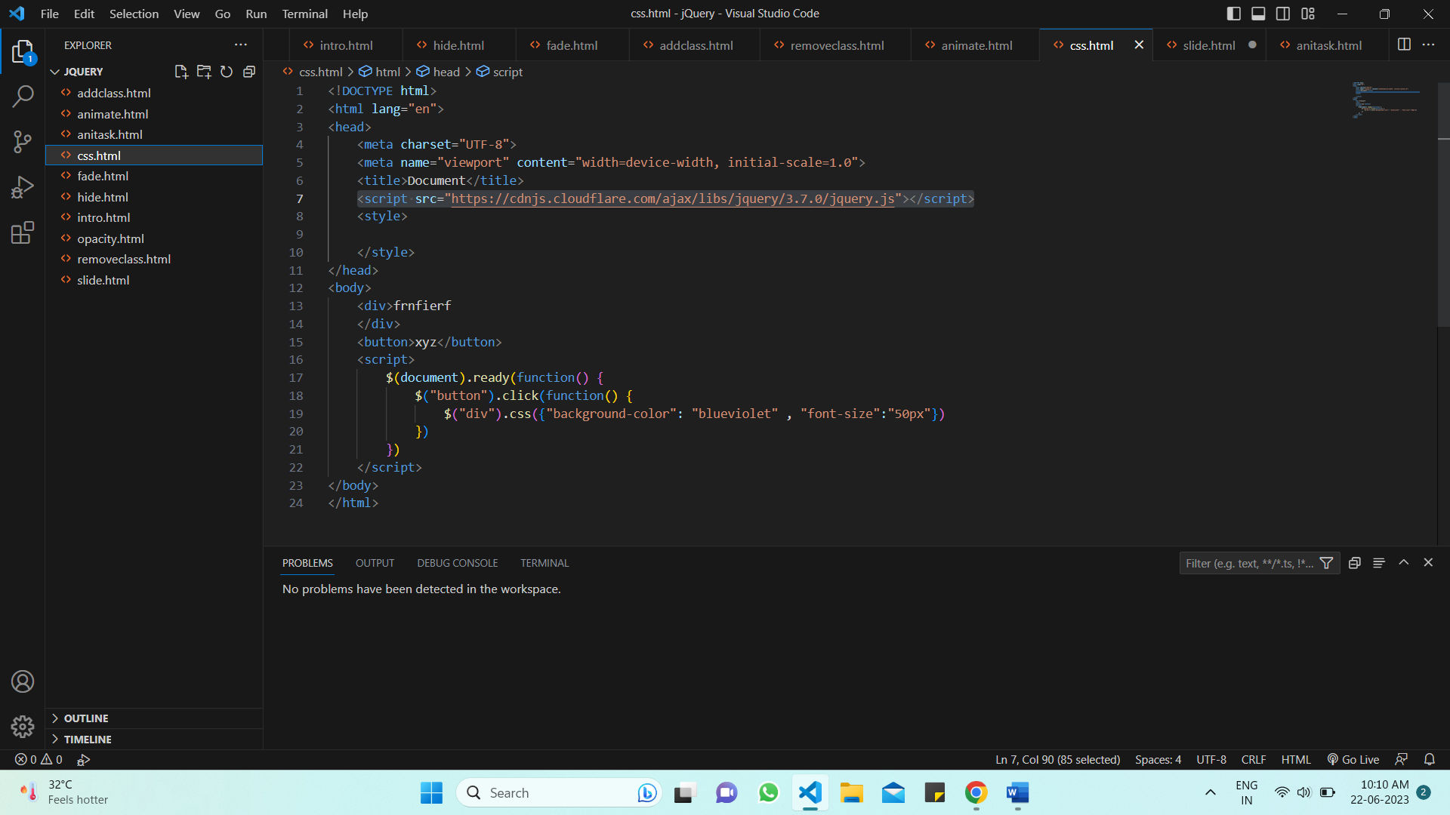

Add class:

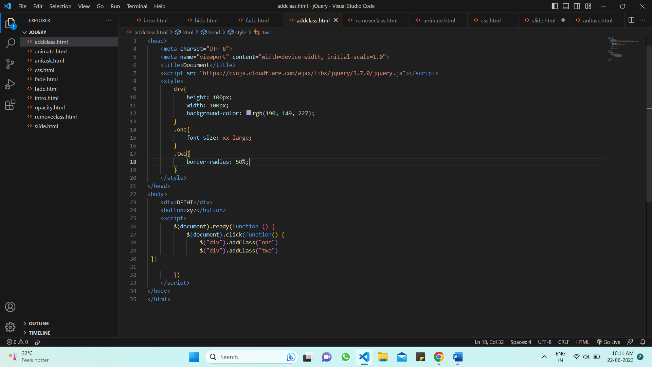

Removeclass:

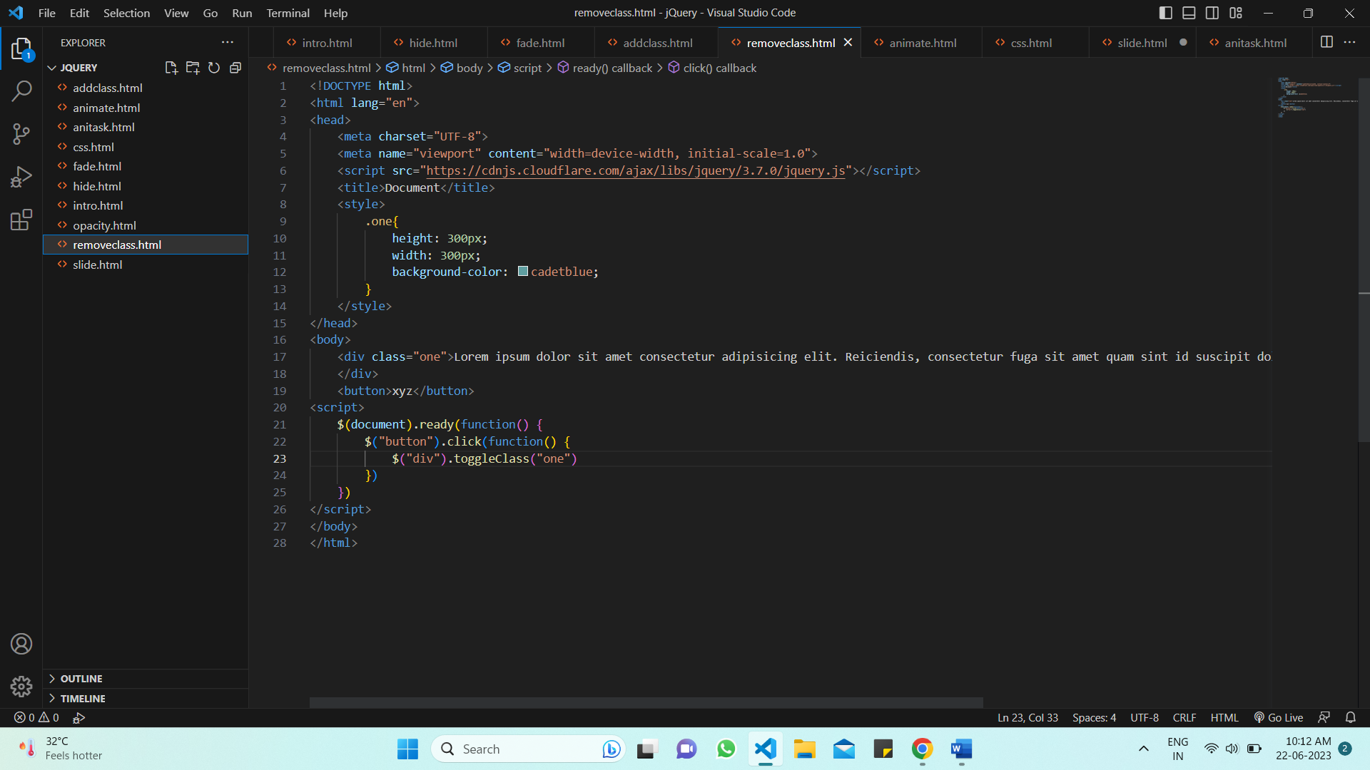

jQuery animation:

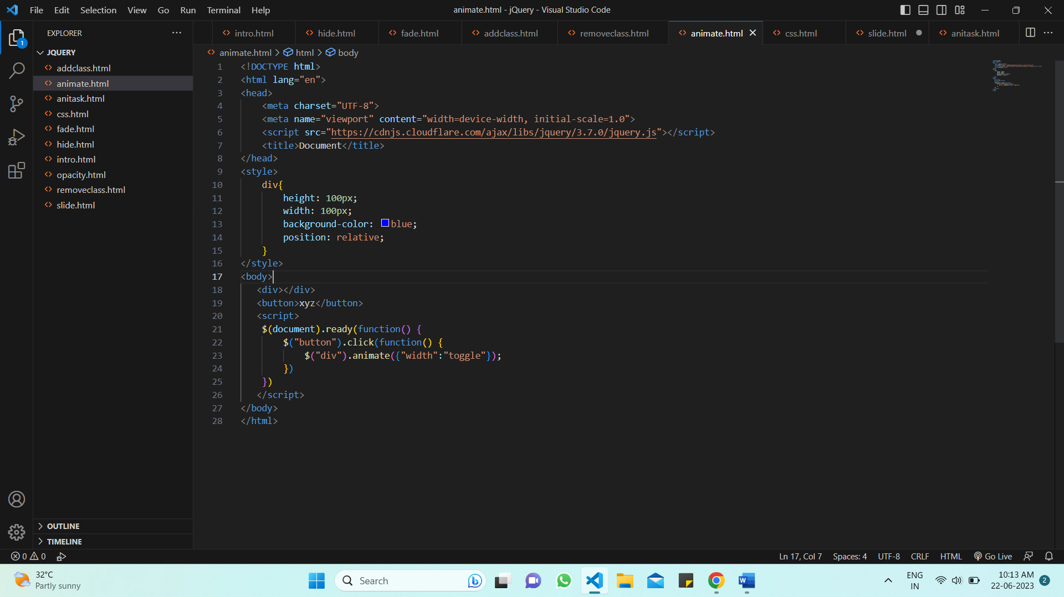

1. **How to crate sliders with animation?**

The element have been slide down, slidetoggle() will slide them up.if the element have been slide up, slidetoggle() will slide them down.

slideToggle() :

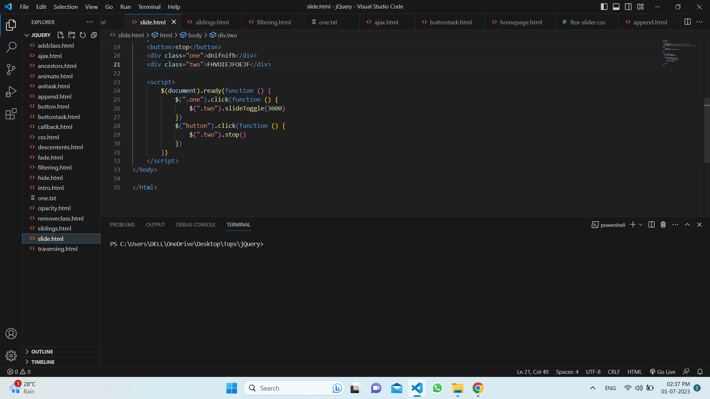

**Slide():**

